**INTRODUCTION TO HTML**

**(CONTINUED.)**

**LAB # 08**



**Fall 2021**

**CSE101L Computer Fundamentals Lab**

Submitted by: **Ali Asghar**

Registration No. :21PWCSE2059

Class Section: **C**

“On my honor, as student of University of Engineering and Technology, I have neither given nor received unauthorized assistance on this academic work.”



Student Signature: ______________

Submitted to:

**Engr. Abdullah Hamid**

March 12, 2022

Department of Computer Systems Engineering

University of Engineering and Technology, Peshawar

**LAB TASKS**

**Task 1:**

Create an HTML webpage with Title “DCSE” and UET logo as a favicon. Everything on this page must be aligned to center. Also include a heading called MY DCSE Profile. Create a list underneath it that contains points like name, registration number, section, semester, lab name and finally last point skills, skills should have nested list containing your skills.

**Task 2:**

After the list leave some space and create subheading “My Classes Schedule” after this Create a Table in HTML Shown Below.

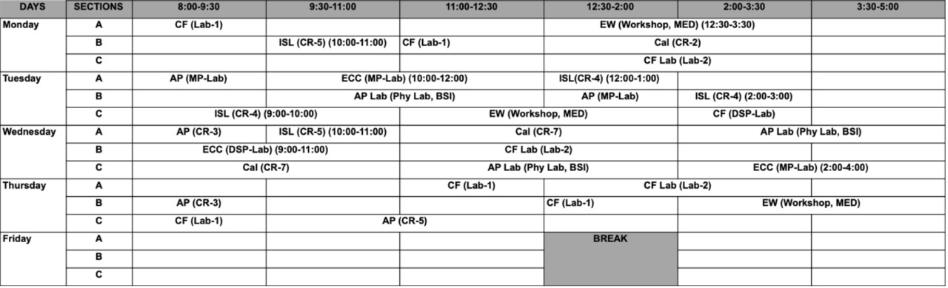

**CODE SCREENSHOT:** 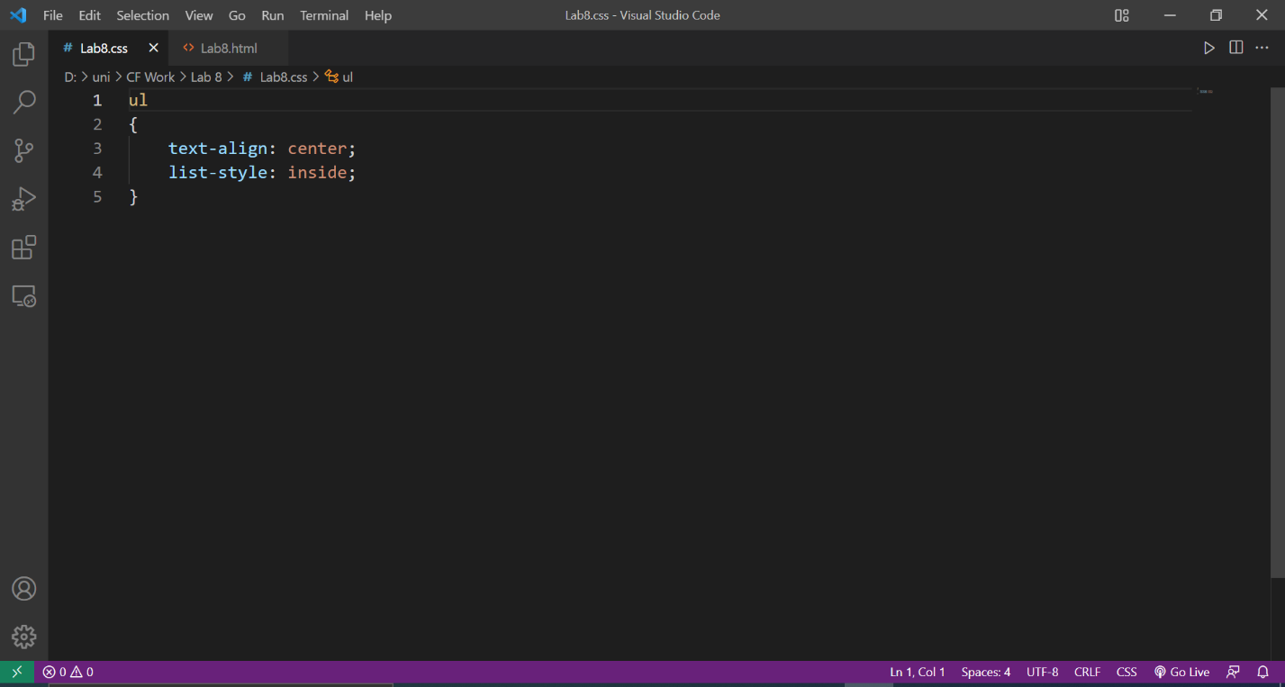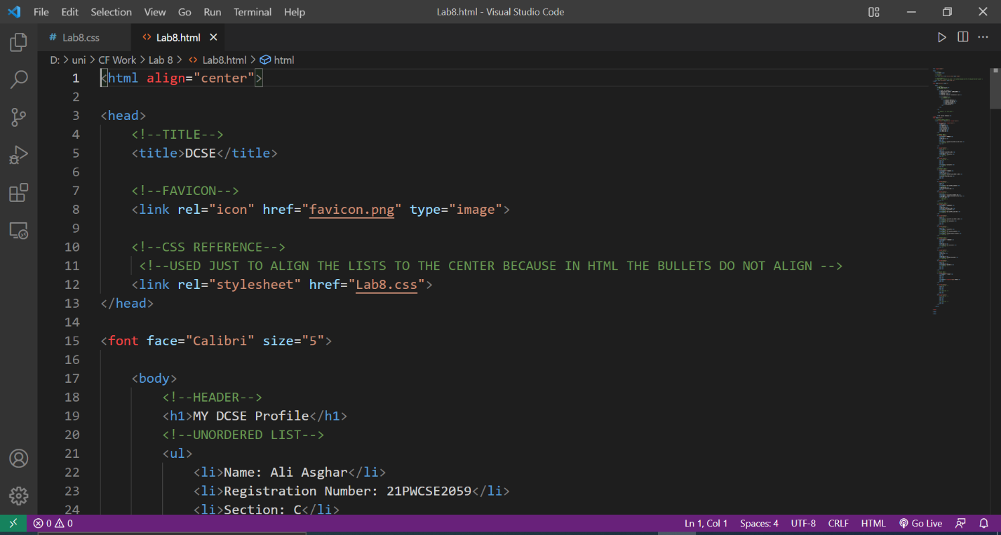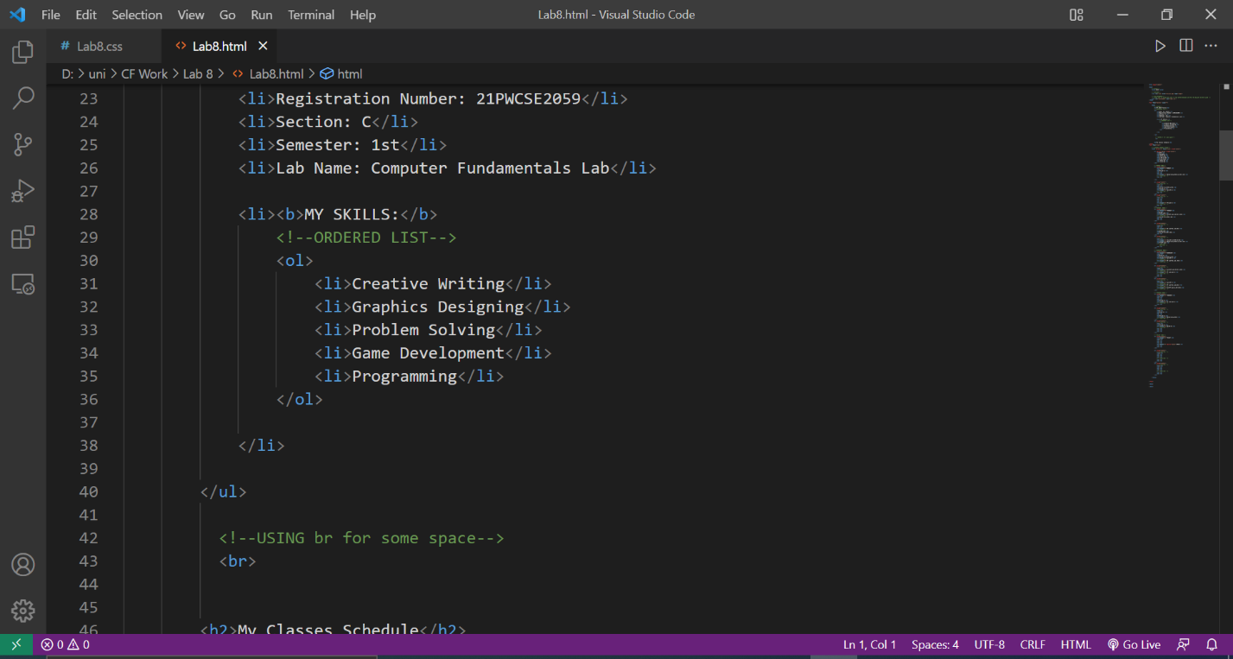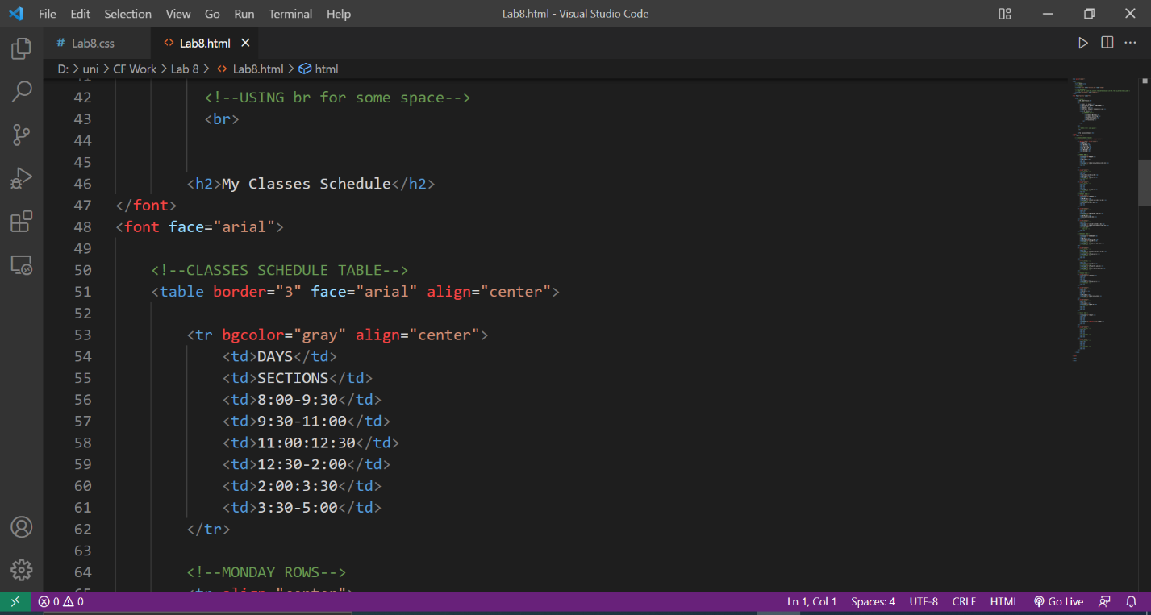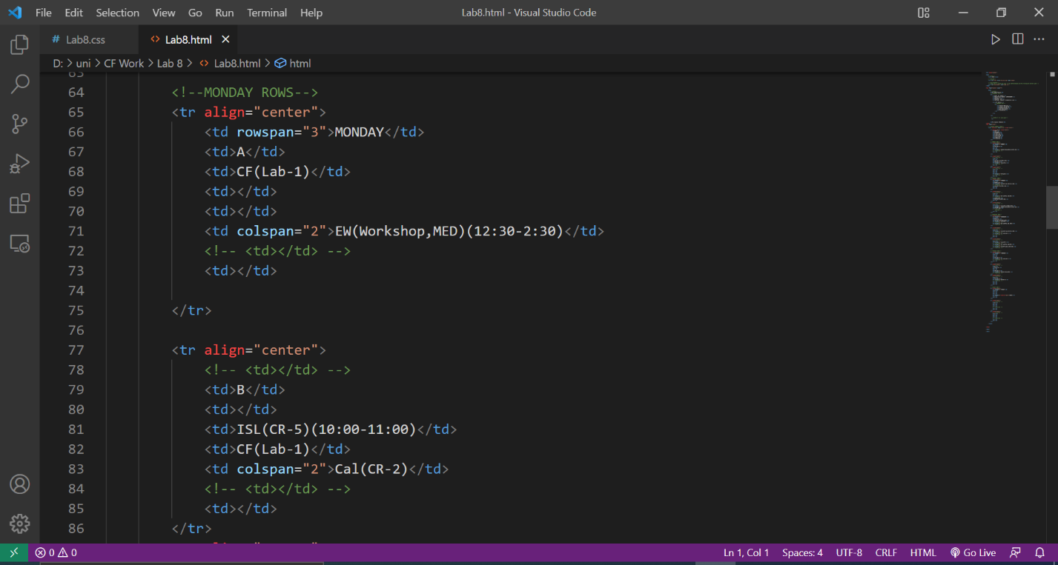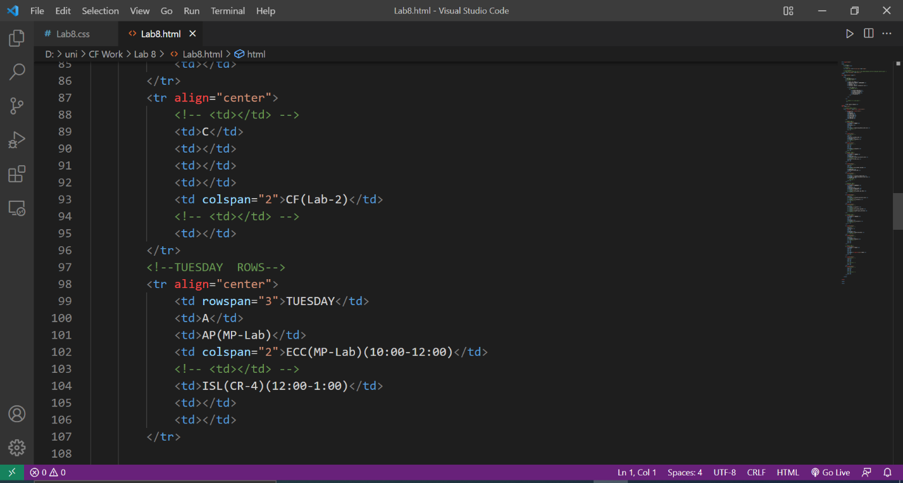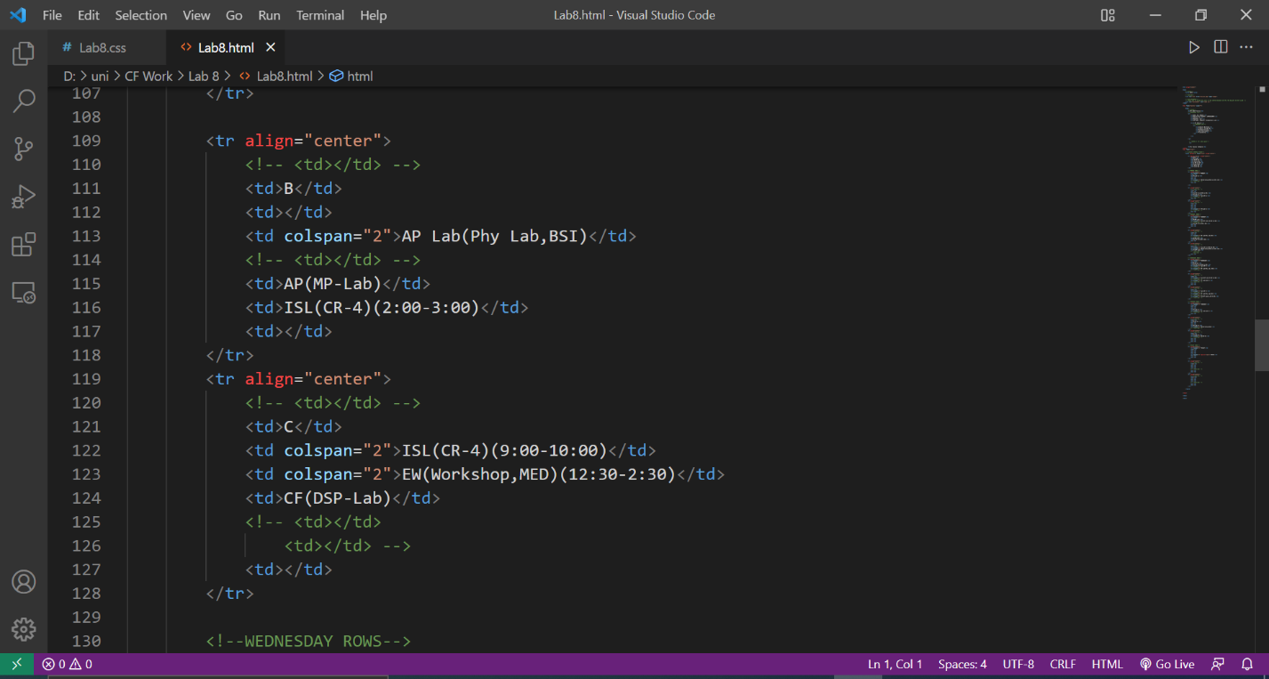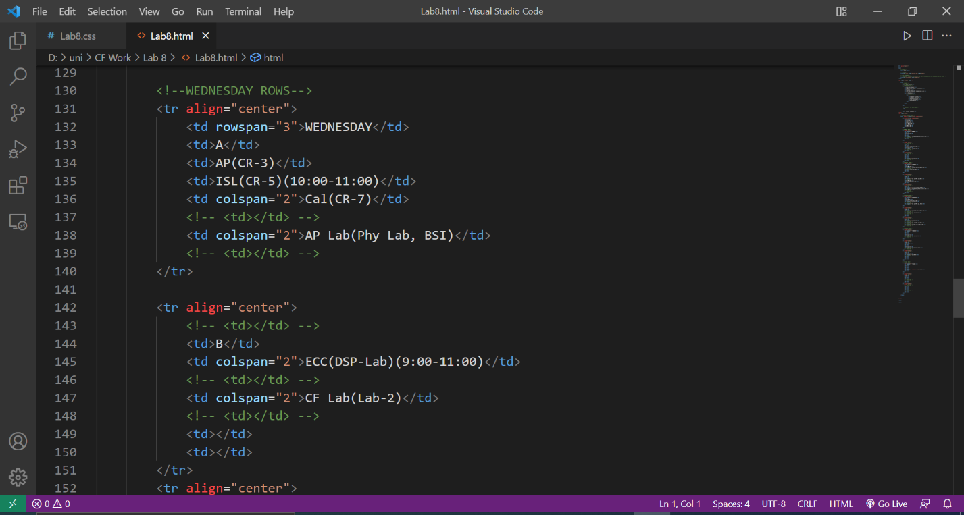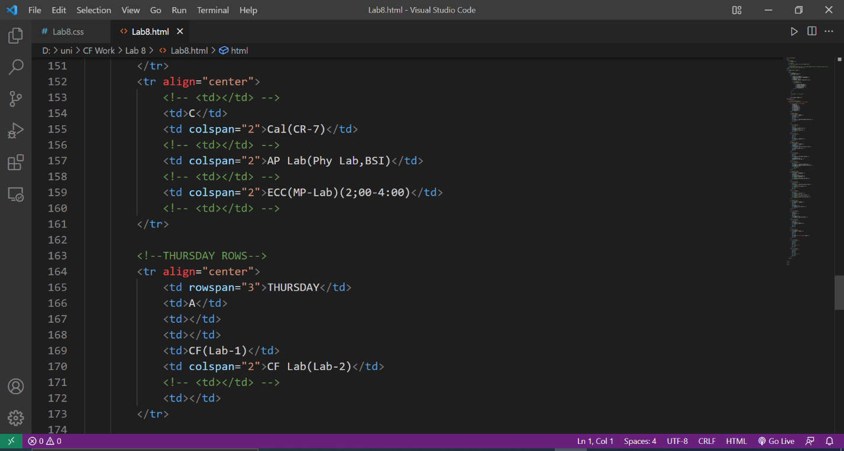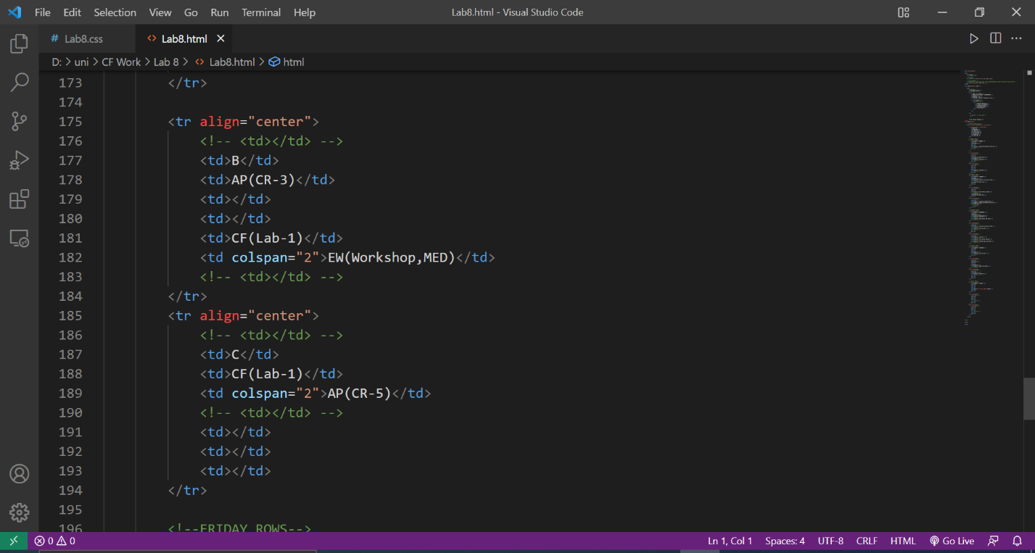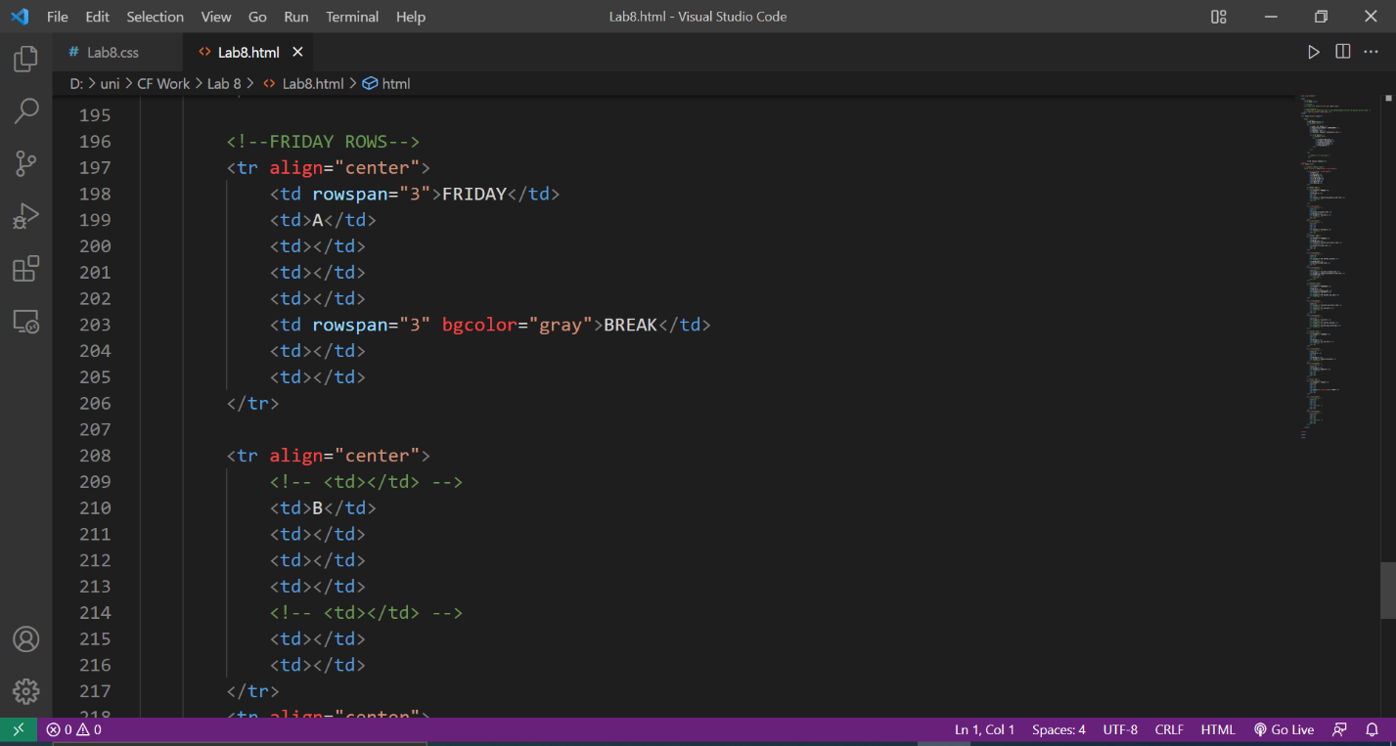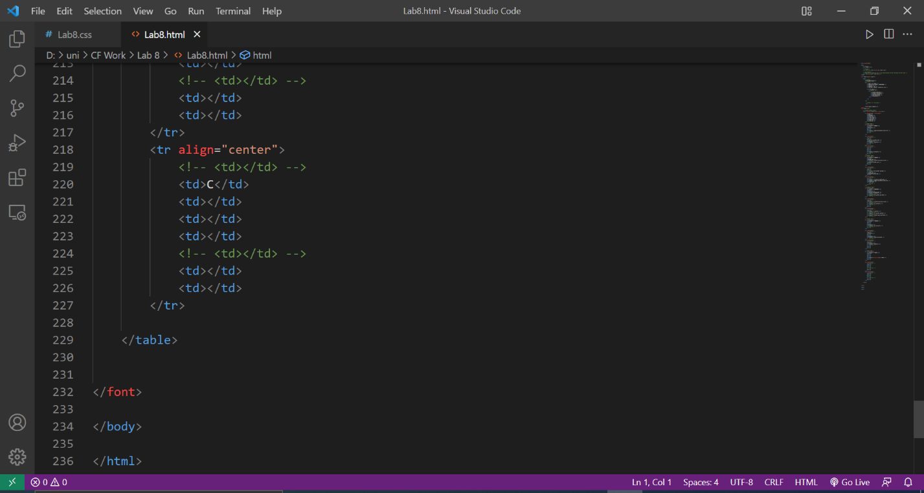

**OUTPUT:**

